Indigenous War Memorial Mural Project

Project Why: Truth Telling - Challenging and supporting a national conversation around recognition of indigenous servicemen and women, honouring their service and achievements.

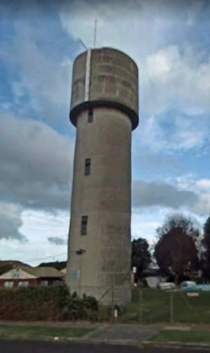
This project will complete the application of a large-scale mural on the Heywood water tower that will serve as a conversation piece highlighting the significant sacrifices made by all our Gunditjmara service men and women, resulting in positive steps toward reconciliation between Indigenous and non-Indigenous members of our community.

Project Aims

- Truth Telling. Sharing their stories. By installing a mural that represents the voice of Indigenous service men and women we start the conversation.

- Education. Supporting a National conversation. The mural will assist to educate community on the achievements, contributions and history of our Indigenous service men and women.

- Acknowledge. Mural plaques will acknowledge and inform community about the significant contributions Indigenous service men and women made for a country they were not equal in.
- Empowering Community. We aim to empower the community by establishing a place for them to celebrate, heal and honour all service men and women.
- Repurposing the Heywood water tower infrastructure to create a reflective mural that adds to a growing Great South Coast Arts Trail.
- Economic Benefit. Increase tourist visitation and spending in Heywood and the broader Glenelg Shire, linking to the Silo Art Trail at the gateway to Budj Bim World Heritage listed landscape

Project Background

Within the Heywood community the stories of the Lovett Brothers and other indigenous men and women service have been passed down through the generations. Elders have spoken for many years about the sacrifices made by their families and how as a community they could honour them.

Over the years there have been ideas raised about how to best recognise our Indigenous men and women but funding and someone to lead the projects have been barriers. Now with confirmed support from Leadership Great South Coast, Gunditj Mirring Traditional Owners Corporation and Wannon Water our leadership team are resourced and ready to assist the Heywood community create this memorial.

The project is located in Heywood, a small town in South West Victoria. This project creates an opportunity to extend and link a growing Great South Coast Art trail to the existing the Silo Art Trail at the gateway to the Budj Bim World Heritage listed Landscape, improving visitor destinations in the region and supporting the development of Indigenous arts while upskilling Indigenous artists.

The town of Heywood shares the inspirational stories of the Lovett Family.
The Lovett family belong to the ‘fighting Gunditjmara.’ Gunditjmara people from South West Victoria earned this title in the 1800s because of their strong resistance to invasion of their Country. The Lovett family have continued this legacy through military service. Overall, 21 Lovett men and women have served Australia abroad in countries including Japan, Vietnam, Korea, and Afghanistan, and all have returned home safely. The family's military record is believed to be unequalled in Australia.
Five Lovett brothers left Lake Condah Mission to fight in World War I (1914-1918). These were Alfred, Leonard, Frederick, Edward and Herbert and they were the children of Hannah (née McDonald), a member of the Kerrup-Jmara clan of the Gunditjmara nation and James Lovett, an Aboriginal man from South Australia.
Incredibly, all five brothers returned home safely. Four of the brothers later went on to serve in the World War II (1939-1945) as well. Their family story is a strong reflection of the contribution that thousands of Aboriginal men and women have made to Australia’s military history, at a time when human and citizenship rights were denied to Aboriginal people at home.
In recognition of their contributions, the building that contains the Department of Veteran's Affairs in Canberra was named Lovett Tower. The stories of the Lovett family contain pain and suffering but also highlight the courage, bravery, and resistance of Aboriginal people.

Our project plan is to create an artwork, large scale mural, on the Heywood (Wannon Water) Water Tower that gives the community a place honour, recognises and heal. Even though the Lovett family have been honoured in Canberra there is still no local recognition of their significant and sustained service.
We have the confirmed support of Gunditj Mirring the Traditional Owner group along with the support of the Aboriginal co-op Winda-Mara.
Wannon Water confirmed written support for the use of the Heywood water tower as our canvas and are fully supportive of the plan to create an Indigenous war memorial mural for the Gunitjmara people and community.
Leadership Great South Coast (LGSC) are our biggest support bringing large scale street art mural experience and project management to this initiative and will support us to lead, manage and deliver this project. The Glenelg Shire Council and the local RSL (letters of support received) are also supportive of this project and will have input along with the broader Heywood community.

Warrnambool area created the first Indigenous War Memorial in Victoria in 2010 and on the 1st of November each year people gather to honour the Indigenous service men and women. We would be honoured to be able to give the Heywood community a reflective place to do the same

Project Deliverables

Stage 1
- Major partners confirmed – via letters of support and authorisation to proceed; Wannon Water, Glenelg Shire, RSL and Gunditj Mirring
- Completion of community engagement and consultation.
Note - First round of consultation at project commencement. Second round TBC before artists commence the mural.
- Funding for project will be secured
- Establish community selection panel to manage expression of interest (EOI) process for artists selection

Stage 2
- Community selection panel confirm appropriate artists. Contract artists to deliver mural.
- Completion of large-scale mural artwork on the Heywood water tower with completion of plaques and landscaping to assist in telling the story and honouring all parties involved.
- Public launch of large-scale Indigenous War Memorial Mural

Appendix 1
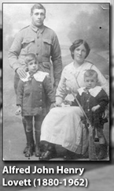

Alfred John Henry Lovett (1880-1962)
Private Alfred Lovett enlisted on 29 July 1915, just before his 36th birthday. After training in the Middle East from October 1915 to March 1916, he fought with the 26th Battalion. He later transferred to the 12th Battalion.
Alfred participated in the battle of the Somme in France, including battles for Poziéres and Mouquet Farm. He returned to Australia in March 1918 and was discharged in June that same year. He was awarded three service medals. As a civilian, Alfred worked as a horse breaker and trainer near Casterton. He was also a well-known jockey. He married Sarah Spring, from Hamilton, with whom he had two sons. They ran a farm in the region.

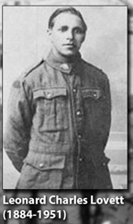
Leonard Charles Lovett (1884-1951)
Leonard, commonly known as Charlie, enlisted on 27 May 1916 and served as a Private in the 39th Battalion of the 3rd Division. He fought on the Western Front, including significant campaigns at Passchendaele in 1917 and Amiens in 1918. He returned to Australia in 1919 and was awarded two service medals.
Many people were surprised to discover that Leonard spoke fluent German. It is thought that he picked up the language while working around Tarrington, near Hamilton, which was settled by German-speaking pioneers.
Among his occupations, Leonard worked as a drover. He married Elsie Maude Clark, with whom he had seven children. Leonard re-enlisted during WWII. Between 1941–42, he was stationed in Australia as a Private with the 3rd Garrison Battalion. His daughter, Alice, served with the Women's Auxiliary Australian Air Force in WWII and his son, also named Leonard Charles, served in the Korean War. His grandson, Mervyn, served in the Vietnam War.

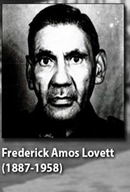
Frederick Amos Lovett (1887-1958)
Frederick enlisted on 13 May 1917. He was a Private in the 29th Reinforcements of the 4th Light Horse Regiment and fought in Palestine. He was discharged on 15 June 1919 and awarded two service medals.
He married Mary Murray Rose and had 11 children. His daughter, Laura Bell, is also a 2013 inductee to the Victorian Indigenous Honour Roll. Frederick worked as a labourer for many years.
Frederick re-enlisted in March 1942. He was a Corporal and served in the Australian Army Catering Corps as a cook. He was discharged from the army in July 1947 at the age of 60. Frederick's grandson, Sergeant Ricky Morris, has recently served in the army with the International Force for East Timor and in Afghanistan.

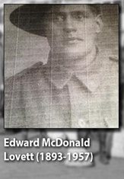
Edward McDonald Lovett (1893-1957)
Edward was known as 'Mac' and enlisted on 17 August 1915. He was a Trooper with the 4th Light Horse Regiment and the 13th Light Horse Regiment that patrolled the Western Front. He returned to Australia in May 1919 and was awarded two service medals.
A single labourer when he joined, Edward married Rose Ann Heron before he shipped out in 1915. The couple had two children, a son and daughter. They ran a billiards hall and pub in Hamilton for a time. Edward also worked as a labourer.
Edward re-enlisted in 1940 and served as a Corporal at the number 12 Garrison Battalion until 1943. Edward's daughter, Sarah Pearl, also served in the Australian Women's Army Service during WWII.

Herbert Stahle Lovett (1898-1976)
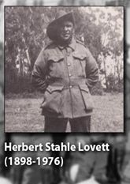
Herbert, the youngest of the brothers to serve in WWI, enlisted in 1917. As he was only 19 years old, his parents were required to give special permission for him to join. He fought on the Western Front as a Private in the 15th Machine Gun Company and participated in the attack that broke the Hindenburg Line in 1918, the last and strongest of the German army's defence. He was discharged in July 1919 and was awarded two medals for his service.
Herbert married Emma Foster from Harrow in 1926 and went on to have six children. His daughter, Iris Lovett Gardiner, was inducted to the Victorian Indigenous Honour Roll in 2012. Herbert was musically gifted and played the organ at Lake Condah's church. He was also the choirmaster and worked in the timber industry.
In August 1940, Herbert re-enlisted as a Private. He served as a cook in the Australian Army Canteen Corps and was discharged in October 1945.

https://www.deadlystory.com/page/culture/articles/anzac-day-2018/the-lovett-brothers

