Expression of Interest – LAndscape gardener
Indigenous War Memorial Mural Project

Leadership Great South Coast Inc. is calling for expressions of interest (EOI) for a landscape gardener to be a part of the Indigenous War Memorial Mural Project. The project is in Heywood, a small town located in South West Victoria.
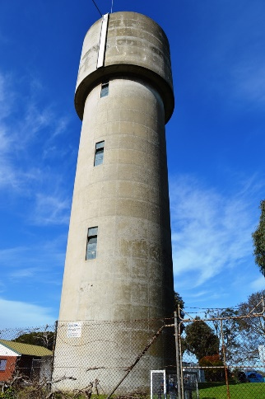
Project Background
Long before they were considered citizens of Australia, Aboriginal and Torres Strait Islander people have had a proud history of contributing to Australia’s defence efforts. With this project we now have an opportunity to acknowledge and honour them.
For many years, the Heywood community and Indigenous elders have spoken of the achievement and sacrifice made by the Gunditjmara servicemen and women and how they could honour their heroic efforts. This vision can now be brought to life through the application of a large-scale mural on the highly visible Heywood Water Tower, which will be accompanied by surrounding landscaped gardens.
Figure 1 - Hunter Street View
The mural will be a legacy and a positive step toward reconciliation between Indigenous and non-Indigenous members of our community. This project will challenge and support a national conversation around recognition of Indigenous servicemen and women and in addition, aims to empower the community by establishing a place for them to celebrate, heal and honour all past and present service men and women.
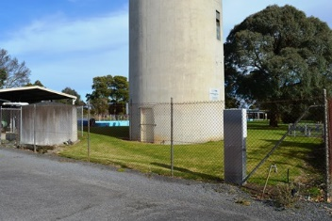
Leadership Great South Coast has initiated and managed similar projects in the region including the Our Story and Ngatanwarr Murals. For more info visit https://lgsc.org.au/projects/
This artwork creates an opportunity to extend and link the growing Great South Coast Art trail to the existing the Silo Art Trail at the gateway to the Budj Bim World Heritage listed Landscape.
Figure 2 - Eastern aspect showing ground to north, east and south of tower
The project is supported by and in partnership with Wannon Water, Glenelg Shire, Gunditj Mirring Traditional Owner Group and Victorian State Government.
All landscape gardeners are invited to submit the below EOI
The selected landscape gardener must have a willingness to work alongside the community as well as working closely with the project group.
The successful applicant will be involved in the following -
- Landscape conceptual design suited to site dimensions
- All associated landscape works and acquisition of any associated permits required to complete the works.
- Sourcing and installation of local species flora to be used
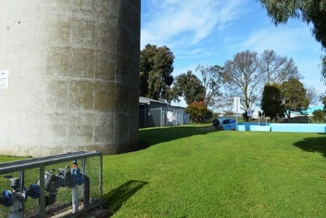
- Installation of new fence for relocated boundary
- Design of any associated structures
- Installation of associated plaques, benches or other associated structures
The successful applicant may be required to be involved in the community consultation process which will help to increase an understanding and insight into the local landscapes, culture and stories.
Figure 3 - Northern aspect showing grounds to the west and rear of tower
The Required Process
Step 1: The selection committee will shortlist three landscape gardeners from the submitted EOI applications.
Step 2: The three shortlisted applicants will be interviewed (in line with current COVID 19 restrictions). From this interview process, the successful applicant shall be selected.
Step 3: The water tower and site dimensions shall be provided to the successful applicant.
Step 4: The successful applicant will develop a conceptual and preliminary design, along with a budget, for presentation to the selection committee for consultation, approval and/or redesign as required.
Step 5: The landscaping is to be completed by March 2021.

Applicant details
Name:

Address:

Phone:
Email:
Website:
ABN:
Insurance policy #:
Selection criteria
Please note the following conditions of entry;
- Demonstrated capacity to deliver landscaping design and works to a budget and timeframe.
- Demonstrated ability to work with a committee and community.
- Knowledge of plant species indigenous to the Heywood area.
- Demonstrated experience working OH&S specifications.
- Public Liability insurance for minimum of $5 million coverage.
- “Working with children” police check.

Applicant’s statement as to why this project is of interest to you and your practice.
(Max 200 words)

Budget
Development of a budget for the landscaping and all associated described works, including the cost of sub-contractors based on your previous projects will need to be supplied. This initial estimate is in no way binding. All insurances, permits, plant licensing and OH&S requirements will be the responsibility of the successful applicant. A final binding budget for the successful applicant will be developed in Step 4 (as mentioned above).

Support material
Attach digital images of your recent works. It is recommended that support material be representative of the type of landscaping that you are proposing to create the garden.

List of supporting materials:
1

2

3

4

5

DECLARATION BY PERSON MAKING THE SUBMISSION
- I state that the above information is true and correct.
- I agree to accept the selection committee’s decision as final.
- I declare this is my own work.
- I understand the time limitations of this project and if selected am willing to travel to Heywood to complete the landscaping works described.

NAME:
SIGNATURE:
DATE:

Note - This project adheres to COVID 19 Government restrictions and guidelines. Timelines and processes may vary accordingly.
Submissions must be received by 29 November 2020
Please submit applications by email to: info@lgsc.org.au with the subject heading Indigenous War Memorial Mural Landscaping EOI

For further details please contact:

Emily Falla, Indigenous War Memorial Mural Project Lead

Email: info@lgsc.org.au Phone: 0408938082

To gain a better understand here are some useful links

https://www.deadlystory.com/page/culture/articles/anzac-day-2018/the-lovett-brothers

https://www.awm.gov.au/learn/schools/resources/anzac-diversity/aboriginal-anzacs/alfred-lovett

https://en.wikipedia.org/wiki/Reg_Saunders
https://www.abc.net.au/news/2019-04-14/land-withheld-from-indigenous-anzacs/10993680
https://www.abc.net.au/news/2020-07-19/aboriginal-soldiers-experience-of-racial-equality-in-vietnam-war/12462118
https://www.budjbimtours.net/

