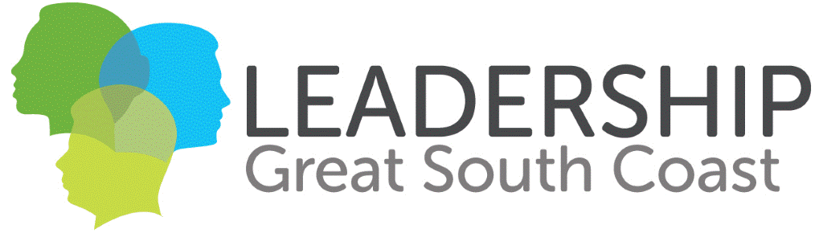

Saving Lives in Moyne Shire Project

We are part of Leadership Great South Coast (LGSC) a not-for-profit program, currently undertaking a community project through which we hope to make a positive difference in our community.
Our community project will assist the Moyne Shire small communities of Koroit, Yambuk, Mortlake and Macarthur (KYMM) to respond more effectively to cardiac arrests, through supporting them to register and make AED’s more publicly accessible.

Statistics show that 5,900 out-of-hospital cardiac arrests across Victoria in 2016, that less than 10% of people survived (Heart Foundation, 2020). Ambulance Victoria has two official response time targets; for communities with less than 7,500 people they aim for a 15 minute or less response to Code 1 incidents in 85% of incidents. In Ambulance Victoria’s 2nd quarter report (Oct to Dec 2019), only 36.6% of Moyne Shire incident response times were 15 minutes or less, most likely due to the distance required to travel and lack of available ambulances.Research has highlighted that Defibrillation within the first three minutes of Sudden Cardiac Arrest (SCA) increases the chances of survival to 70 percent.

Shock within one minute of collapse raises the survival rate to 90 percent (DeFib for Life 2019). The other benefit of Automatic External Defibrillators (AEDs) is that, according to the NSW Government Health Department, “Anyone can use a defibrillator – they have verbal and visual instructions to guide you”. Therefore, the more AEDs that are registered and accessible, within the Moyne Shire, the greater the number of lives that will be saved.

With approximately 17,000 residents in the Moyne Shire, the existence, registration, and accessibility of AEDs across each township is variable and unknown in many cases. Registration of AEDs is not compulsory and is not resourced to ensure implementation, by a single organisation; it relies on community knowledge and commitment. In our Project, we will be focusing on four communities with which the Team members either already have a relationship, or which are of significant population, to warrant an increase in the existence, registration and accessibility of AEDs.

What are the expected outcomes of the project?

- To increase the survival rate of cardiac arrest victims in each of the four communities in Yambuk, Mortlake, Koroit, and Macarthur
- Create a Gap Analysis Report of the current and required numbers, status, and locations of AEDs in each community
- Register AEDs within four towns and make at least one publicly accessible 24 hours a day/7 days per week

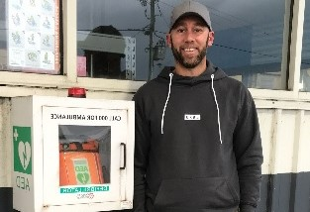

FAQ’s
- Is Leadership Great South Coast (LGSC) associated with any AED commercial manufacturers?
No this is a not-for profit community project
- If I make my AED accessible, will LGSC take any ownership?
No, all ownership and responsibilities are with the owner of the AED.
- If, I am happy to be an AED owner, will you provide me with an AED?
Not necessarily, but we will report on any opportunities.
- How will you make a difference to the lives in my community?
By making sure AEDs are registered with Ambulance Victoria, Ambulance Victoria will have access to the whereabouts of AEDs in your community and can assist in an 000 call. If at least one AED can be made 24/7 accessible; survival rates from a cardiac arrest could significantly increase.
- Who is responsible for moving my AED, once I am happy to have this accessible 24/7?
We will assist in the move and report back on opportunities that exist, so there is little or no cost to you.
- Who will pay for a weather-proof cabinet to make my AED accessible 24/7?
Our Project has a small budget to purchase a limited number of cabinets to make AEDs accessible.
- What are the benefits to our community of registering our AED?
More people would have access to this defibrillator, ultimately saving more lives.
- What are the benefits to our community of making our AED 24/7 accessible?
More people would have access to this defibrillator, ultimately saving more lives.
- What would my responsibilities be as the registered owner of our AED?
As the registered owner, you would be responsible for registering with Ambulance Victoria and the upkeep of your defibrillator.

FAQ’s Cont.

- Is a heart attack the same as a cardiac arrest?
This is not the same. A heart attack is when an artery in the heart gets blocked or becomes too narrow for blood to flow through normally. This prevents blood from getting to some parts of the heart muscle. This damages the heart, sometimes permanently.
A cardiac arrest is when the heart suddenly stops beating. This means that the blood stops flowing to all parts of the body including the heart and brain. As soon as this happens the process of death starts. At some point, usually within 10 minutes, the damage to the heart and brain will become so great that it can’t be reversed. The chance of survival drops by around 10% every minute after the heart stops.
With a cardiac arrest, urgent treatment is required to keep the blood moving around the body and to try to ‘restart’ the heart. When CPR and AED are provided within the first few minutes the chances of survival are the greatest. (Heart Safe Communities, 2020)
- Do you provide training in the use of the AED?
We do not provide training ourselves; we would be happy to put you in touch with Ambulance Victoria, who could assist.
- What evidence do you have that a 24/7 accessible AED will not be damaged?
The Moyne Shire has installed several of these defibs across local towns and monitored their condition over the years. We have been told these have not been damaged and gone through several major events.
- How many registered and accessible AEDs do we need in our community?
We aim to have at least one that is accessible to the public 24/7

Leadership Great South Coast Questions
  - Are you the registered owner of the AED?
  - If yes, would you mind sharing your model name with us?
  - Is your AED operational?
  - Do you regularly replace pads and batteries as per the guidelines of your AED?
  - Where, exactly is your AED located?
  - Can I take a photo of your AED for research purposes?
  - How do you find being responsible for an AED?
  - Have you registered your AED with Ambulance Victoria?
  - If no, would you be open to the idea of us assisting in getting your AED registered with Ambulance Victoria? (When can we schedule this in?)
  - Can you think of any benefits of having your AED registered with Ambulance Victoria? Please specify.
  - Can you think of any benefits to making your AED accessible to the public? Please specify.
  - Is your AED publicly accessible? If not why? (e.g. security reasons, it’s private, had not thought about it)
  - Can you see the benefit of making your AED accessible 24/7? Research shows there has been little to no damage to those operators who have done so. The Port Fairy library located theirs outside to have their AED accessible 24/7 and have never reported any damage.
  - Would you consider making your AED accessible 24/7 to the general public?
  - Would any related costs to making your AED accessible 24/7 play a role in moving your AED to a publicly accessible spot that can be accessed 24/7?
  - Did you know there are secured cabinets that could protect your AED?
  - Do you know of any other AEDs either in this town or another?
  - Is there anyone else you might recommend as an AED owner or can think of a good location to have one?

