Expression of Interest

Tarrington Water Tower Green Space
A beautiful and productive green space that facilitates intergenerational social connection, recreational time in nature, and shared community responsibility.

Leadership Great South Coast, in partnership with the Tarrington Progress Association and Tarrington Senior Citizens, is calling for expressions of interest from landscapers to complete the major works required to establish a community green space at the base of the Tarrington Water Tower (7892 Hamilton Highway, Tarrington, VIC 3301).

Tarrington is an idyllic community, close to Hamilton in the Southern Grampians Shire. In the middle of this town sits a decommissioned water tower. The Tarrington community would like to transform this unused piece of land into a green space for the whole community to enjoy. The final product will be an accessible, multi-purpose green space that will encourage inter-generational connection between the senior citizens and school children.

Further details about the planned green space can be seen in the initial design and list of requirements below.

Selection Process
Step 1: From the completed expressions of interest, the landscaper with the strongest application will be invited for an onsite meeting (or online if necessary) with the project team to further discuss the project. If the landscaper is considered well suited to the project after this meeting, they will be selected.

Step 2: In consultation with the project team, the selected landscaper will finalise the design and cost of the project. The project team will review the final design and cost and, after any required alterations or negotiations, a contract will be written up for the landscaping work.

Step 3: The work will commence once the contract is signed off by all parties. The date of completion will be negotiated between both parties, likely to be late November.

Applicant details
Name:
Business Name:
Address:
Phone:
Email:
Website:
ABN:
Are you registered with the Victorian Builders Authority? (Yes/No)

Budget
Based on the attached design and list of requirements, please develop a draft budget for the project. Please itemise the budget based on the list of requirements below and include both labour and equipment costs. This budget is only intended to be an estimate and a final cost will be agreed upon with the selected landscaper.

Prior experience
Please list two prior projects the applicant has overseen and completed, preferably projects of a similar nature to the Tarrington water tower green space. Please attach evidence of these projects such as photographs, digital images or links to websites.
1
2

DECLARATION BY PERSON MAKING THE SUBMISSION
- I state that the above information is true and correct.
- I agree to accept the selection committee’s decision as final.
- I declare this is my own work.
- I understand the time limitations of this project and if selected am willing to travel to Tarrington to complete the landscaping.

NAME:

DATE:

Submissions must be received via email by 5pm, Friday 22 October 2021
Please submit applications and make inquiries to Heather Smillie, Project Lead:
Email: hjsmillie@gmail.com
Phone: 0412 426 372

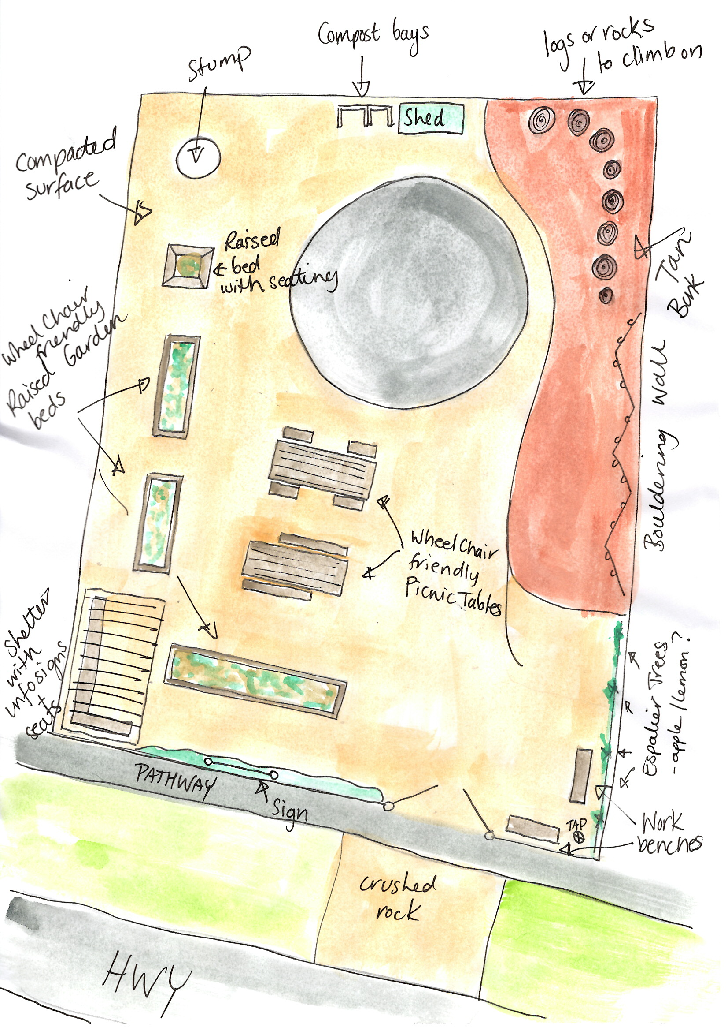
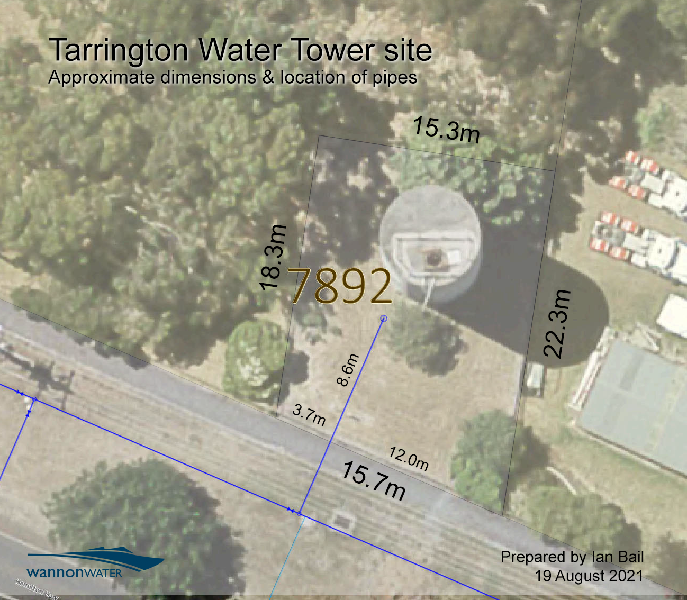
TARRINGTON WATER TOWER GREEN SPACE DESIGN
REQUIREMENTS (IN ORDER OF PRIORITY)

- Removal of three established trees and other small foliage
- Crushed rock for driving over nature strip (approximately 2m x 4m)
- Leveling and compacting the ground (310 square meters)
- Three raised garden beds (approximately 3m long by 1m wide)
- One square raised garden bed with in-built seating (approximately 1.7m sides)
- Two wheelchair friendly wooden picnic tables (approximately 2m long)
- Small shed to store with gardening equipment (approximately 3m wide and 2m deep)
- Three espalier trees and a small collection of other native plants
- Small collection of large logs or rocks for children’s play
- Information shelter without walls (approximately 4m long and 3m deep)
- Two workstation benches for gardening

